CTCA National Specialty
Macungie Memorial Park
50 Poplar Street Macungie, Pennsylvania 18062
1 October 2026 – 4 October 2026

Theme: “Cairn Kick Off”
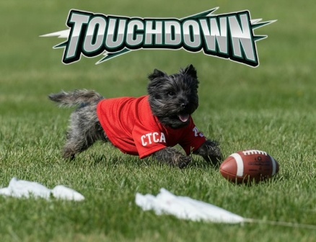
Host Hotel
Sleep Inn
327 Star Road
Allentown, PA 18106
610-395-6603/6604

Room Rate: $115 per night
One-time pet fee: $60
Free breakfast buffet
Reservations to obtain CTCA rate must be made by 1 September 2026

National Specialty Contacts

Awards  Patti McCully  pattimccully@gmail.com | Table Decorations  Pam Davis  davispcjg@aol.com  Connie Burnley  burnleycs@verizon.net | National Specialty Chair & Hotel Liaison  William Kent  Madeline19@aol.com
Health & CTCA Foundation  Tamara Erickson  tammy@tammyerickson.com |  | Dinner Reservations  Kathleen Onorato  Rodneysmom53@aol.com
Gift Bags  Kathleen Onorato  Rodneysmom53@aol.com | Performance  Pam McDonald  maidenstonepgm@aol.com  Connie Burnley  burnleycs@verizon.net | Hospitality Tent & Sweeps  Joyce Adams-Taylor  jkaatskill@gmail.com  Debby Lajeunesse  dlajeunesse@hotmail.com
Ways & Means  Judy Meyers  yojudy@yahoo.com | Award Certificates  Winnie Bixler  winner@mwbitler.com | Advertising & Education  Mary Beth Havens  havenshire@aol.com

Week at a Glance

Monday & Tuesday (28 & 29 September)
- Performance events at different locations

Thursday (01 October)
- Hatboro Dog Club – Mid-morning ring time requested Ring 14 – Macungie Memorial Park
  - Judge: John Constantine
  - Superintendent: RAU

- Meet and Greet – Delta Hotel 7736 Adrienne Drive, Breingsville, PA
  - Taco Bar with dessert: 4:30 – 6:30 PM - $35 per person
We will congregate and meet in the bar area – cash bar

The Delta Hotel is not a pet-friendly property. The Delta Hotel is two minutes from the host hotel just across Route 100.

Friday (02 October)
- Roving National Sweeps – Early judging requested - Ring 14 - Macungie Memorial Park
  - Sweeps Judge: Dr. Mary Goss
  - Superintendent: RAU

- Hatboro Dog Club – Mid-morning rign time – Macungie Memorial Park
  - Judge: Alex Wheeler
  - Superintendent: RAU

- Health Testing @ Macungie Memorial Park in building by pool: 11:00 – 3:00 PM

- Friday Evening Meal Get Together – Delta Hotel – 7736 Adrienne Drive Breingsville, PA
  - Burger Bar with dessert - 4:30-6:30 pm - $35.00 pp (beef, vegetable and turkey patty options)
We will congregate in the bar area. Cash bar available. The Delta Hotel is not a pet-friendly property.

Saturday (03 October)
- Devon Dog Club – Ludwig’s Corner, PA
Early ring time requested
  - Judge: TBD
  - Superintendent: MB-F

- Picnic lunch available in basement of stone building at Macungie Memorial Park. A la carte meal.

Sunday (04 October)
- CTCA Roving National Specialty – Macungie Memorial Park – Ring 14 – Early morning judging
  - Superintendent: MB-F
  - Judge: Linda Firth
  - Ring Stewards: Pamela Davis & Connie Burnley

Dinner Reservation Form

Taco Bar: Thursday, 01 October, 4:30 – 7 pm. Come and go as you please.
Delta Hotel – 7736 Adrienne Drive, Breingsville, PA

Cost: $35.00 pp.
Names of those attending:

_____________________________________________________________________

_____________________________________________________________________

Burger Bar: Fiday, 02 October, 4:30 – 7 pm. Come and go as you please.
Delta Hotel – 7736 Adrienne Drive, Breingsville, PA

Cost: $35.00 pp.
Names of those attending:

_____________________________________________________________________

_____________________________________________________________________

Mail form and payment to: (make check payable to CTCA)

Kathleen Onorato
118 McLaughlin Street Total:_______
Glen Cove, NY 11542
(516) 524-3068

